**Hive documentation**

**Partition table example**

Created database ust

Created table logs and loaded the data .Also created a partition table partition_log and moved the data to it.

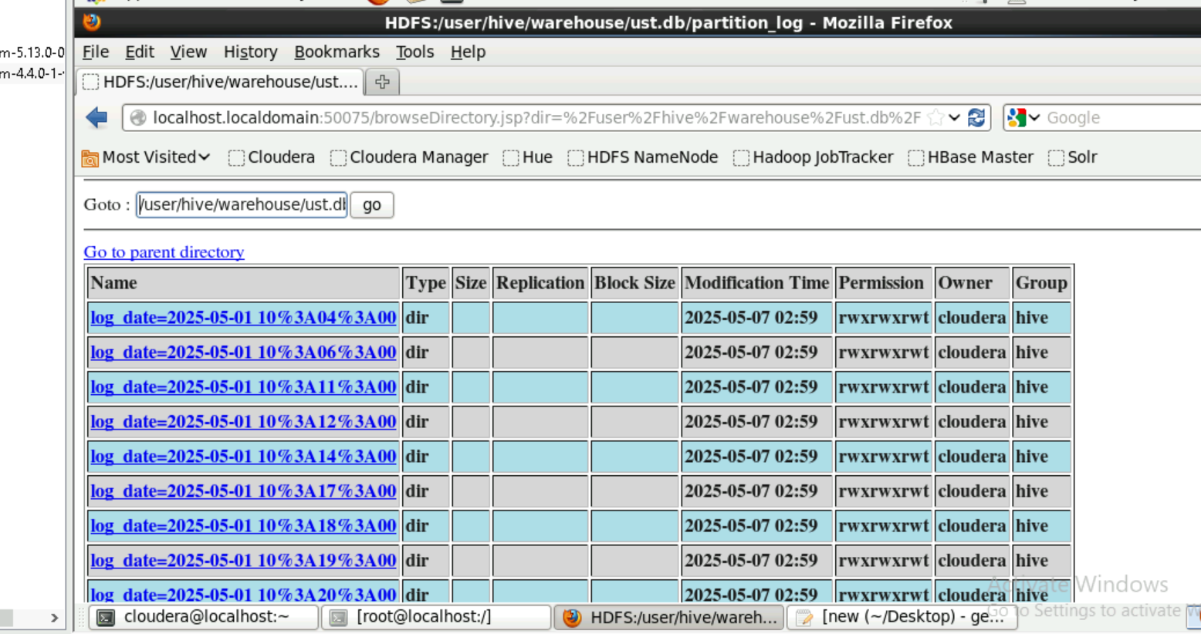

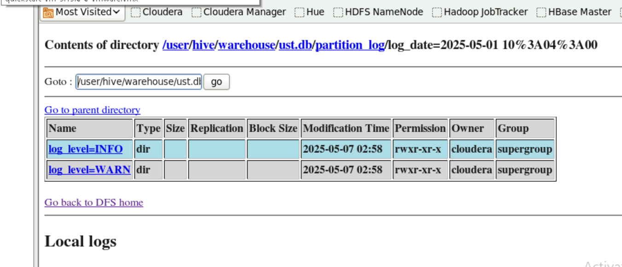

Partition was done on the column log_date and log_level